

|  |
| --- |
|  |

**Bitbucket Server Backup Client Utility**

Document Control

|  |  |
| --- | --- |
| **Title**: | **Bitbucket server backup client utility** |

|  |  |  |
| --- | --- | --- |
| **Revision history**: | | |
| ***Version No.*** | ***Release Date*** | ***Author*** |
| 0.1 | 31-August-2016 | Saikrishna Gogula |
|  |  |  |
|  |  |  |
|  |  |  |

|  |  |
| --- | --- |
| **Significant changes**: | |
| ***Version No.*** | ***Details*** |
| 0.1 | Initial Draft Version |
|  |  |
|  |  |
|  |  |

|  |  |
| --- | --- |
| **Availability**: | |
| ***Copy*** | ***Location*** |
| Soft copy |  |
| Hard copy |  |

|  |  |
| --- | --- |
| **General**: | |
| **Approved by**: |  |
| **Released by**: |  |

|  |
| --- |
| **Distribution list**: |

|  |  |  |
| --- | --- | --- |
| **Name** | **Role** | **Approver/Reviewer** |
| Sumanjit Brar | Strategy Architect | Reviewer |
| Daniel Lane | Chief Engineer | Approver |
| Mikkal Sveum | Portfolio Testing Infrastructure Manager | Approver |
| Sunil Kothyala | Senior Manager | Approver |

**Table of Contents**

Table of Contents

1 Overview 5

2 Purpose 6

3 Steps to Create Backup and Restoration 7

# Overview

Bitbucket server backup client utility provides two command line programs which can be used to generate full backup of Bitbucket server and to restore the Bitbucket server from the backup file which is created using this utility.

# Purpose

The purpose of this document is to outline the steps on how to take the backup of Bitbucket server and restore it using Bitbucket server backup client utility.

# Steps to Create Backup and Restoration

**Step 1:** Install Bitbucket Server using CA RA Flow.

**Step 2:** Create couple of projects and repositories as shown below:

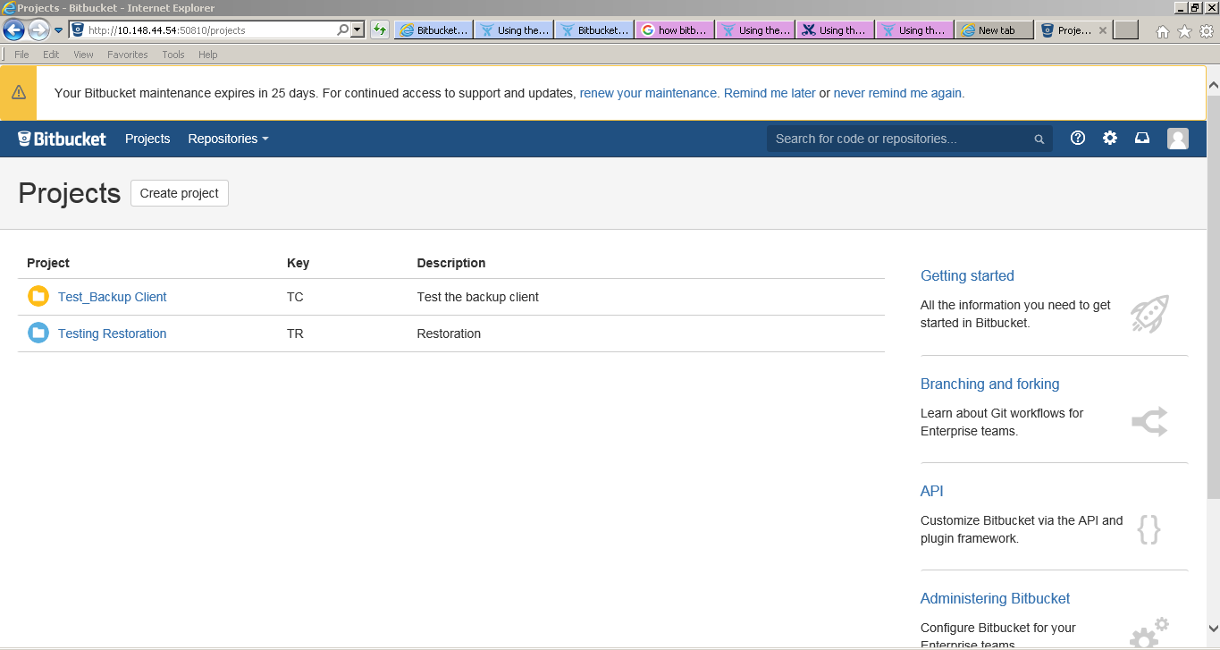

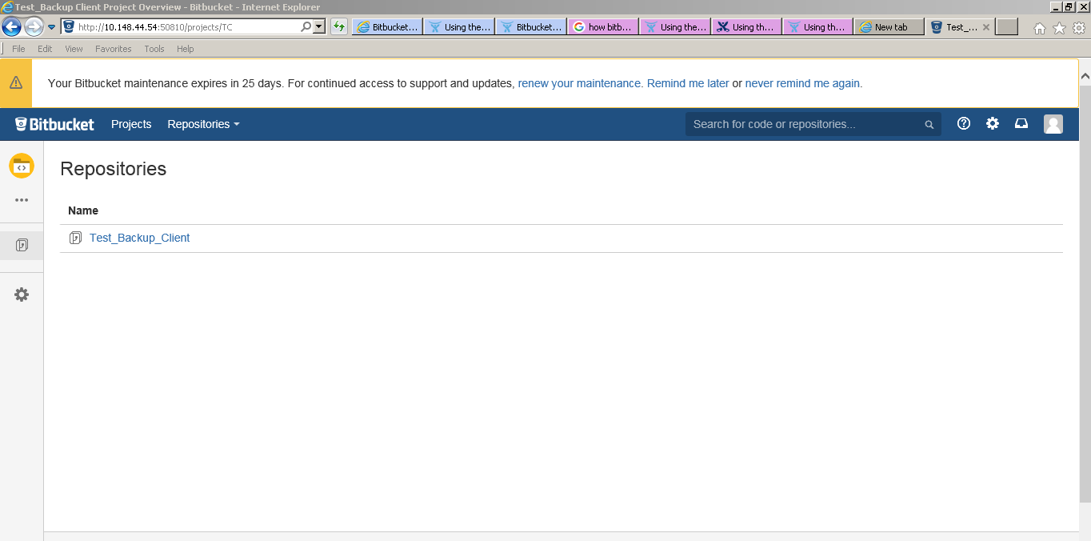

**Step 3:** Push some source files and do check-ins in to repository as shown below:

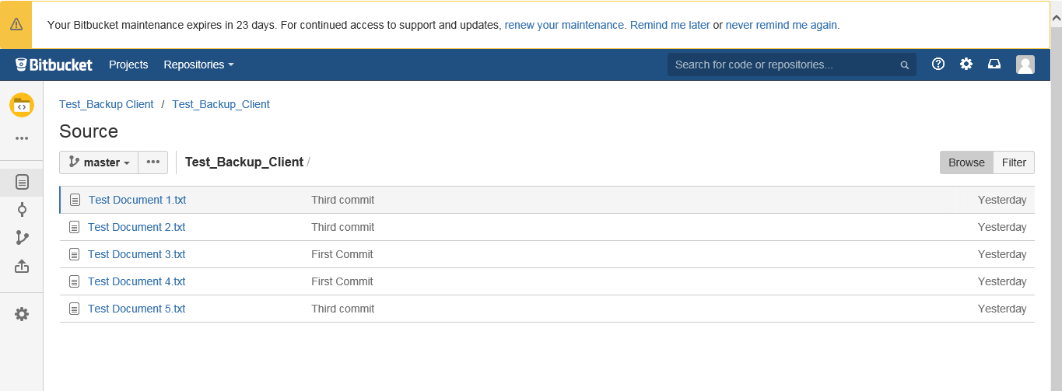

**Step 4:** Create users in Bitbucket. Please find the sample users as shown below:

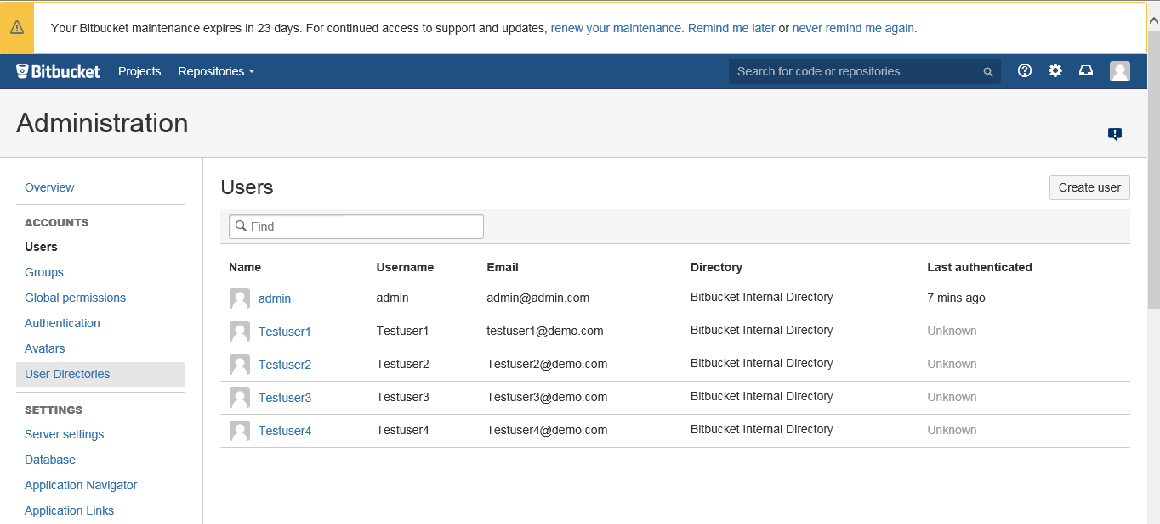

**Step 5:** Create groups in Bitbucket. Please find the sample groups as shown below:

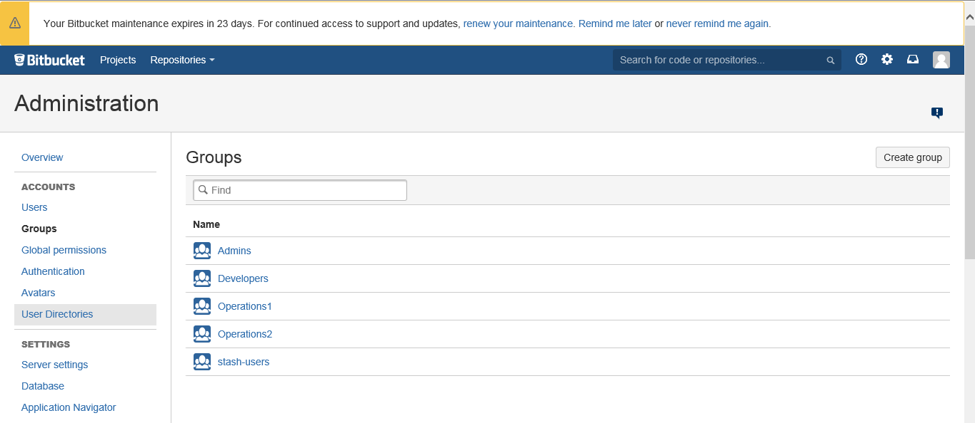

**Step 6:** Add users in to groups as shown below:

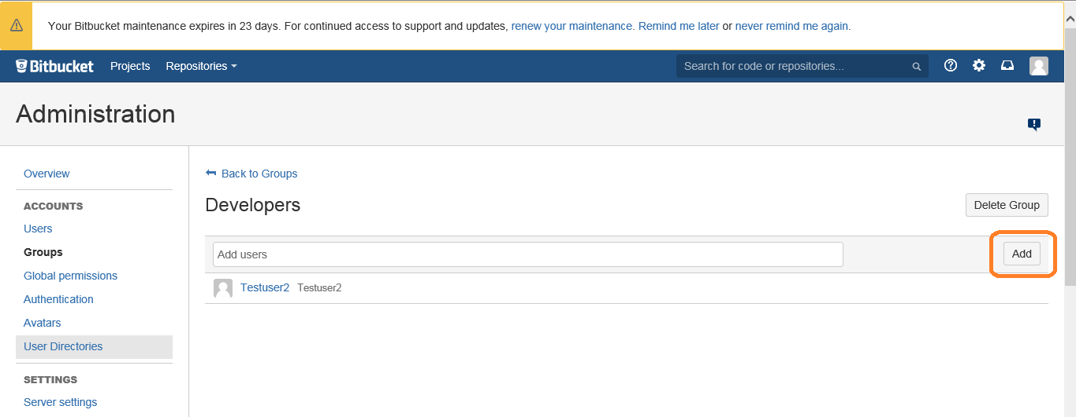

**Step 7:** Provide Global permission to users and groups as shown below:

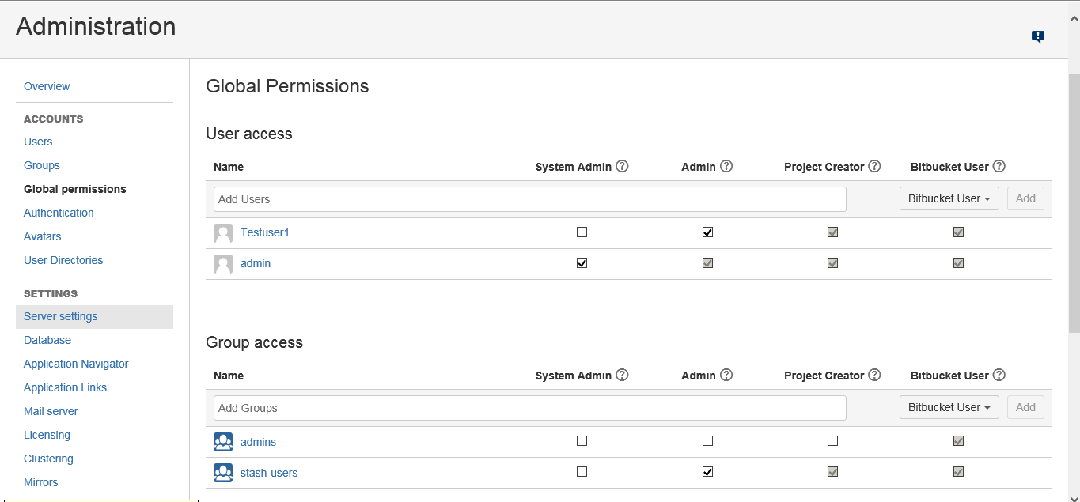

**Step 8:** Provide repository permissions for specific repository to groups as shown below:

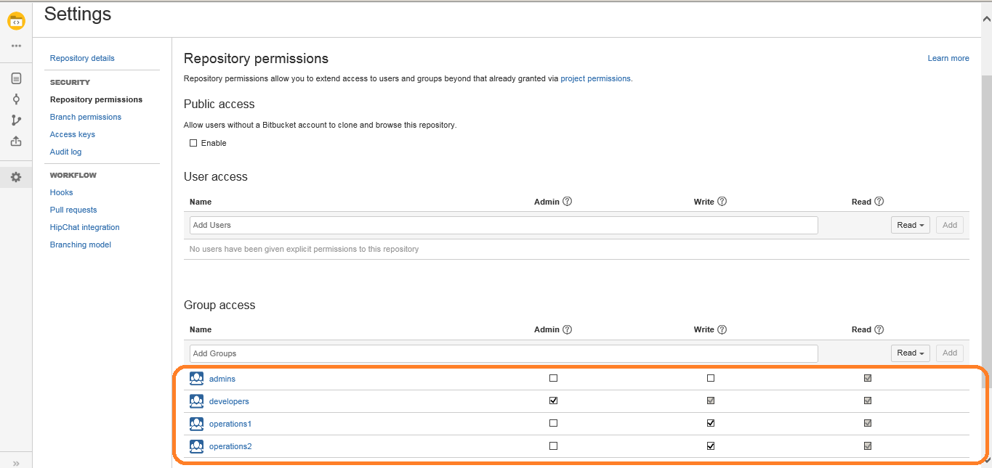

**Step 9:** Provide project permission to specific project to groups as shown below:

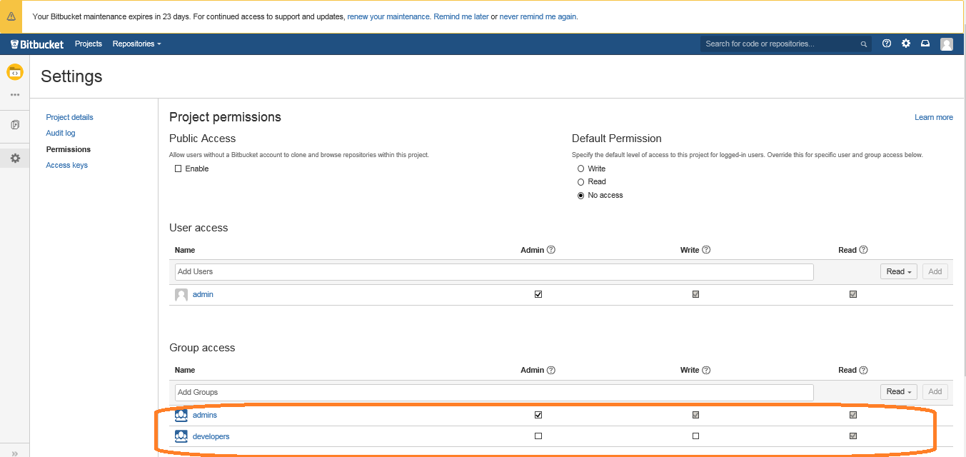

**Step 10:** Download bitbucket Server backup client 3.2.0 (As 3.2.0 version is compatible with Bitbucket Server 4.6.2) from the below URL:

<https://marketplace.atlassian.com/plugins/com.atlassian.stash.backup.client/versions>

**Step 11:** Extract the zip file and copy to any path on the server where bitbucket is installed as shown below:

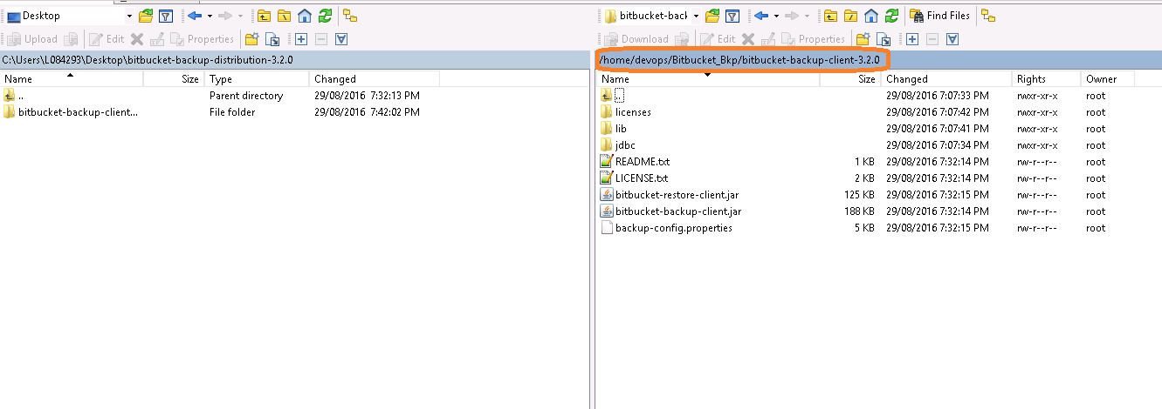

**Step 12:** Now take the backup of existing bitbucket instance by navigating to the bitbucket server backup client directory and by using the below command:

java -Dbitbucket.password="admin" -Dbitbucket.user="admin" -Dbitbucket.baseUrl="http://10.148.44.54:50810" -Dbitbucket.home=/var/opt/data/atlassian/bitbucket-home -Dbackup.home=/home/devops/Bitbucket_Bkp -jar bitbucket-backup-client.jar

Once the above command successfully executed we can see the below output and backup tar file under backup folder:

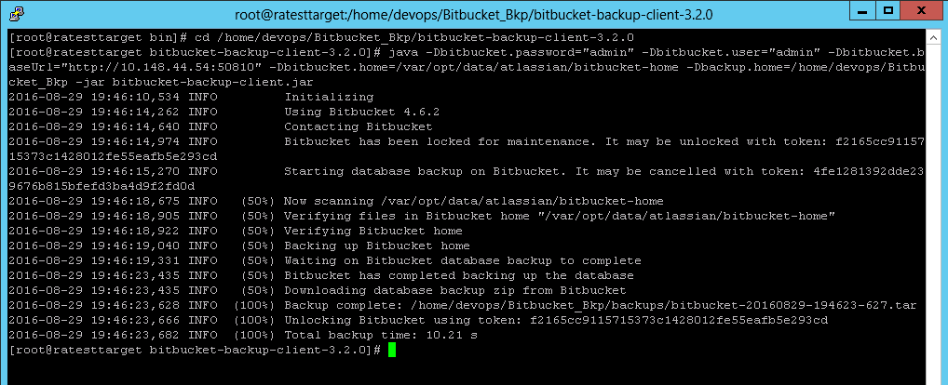

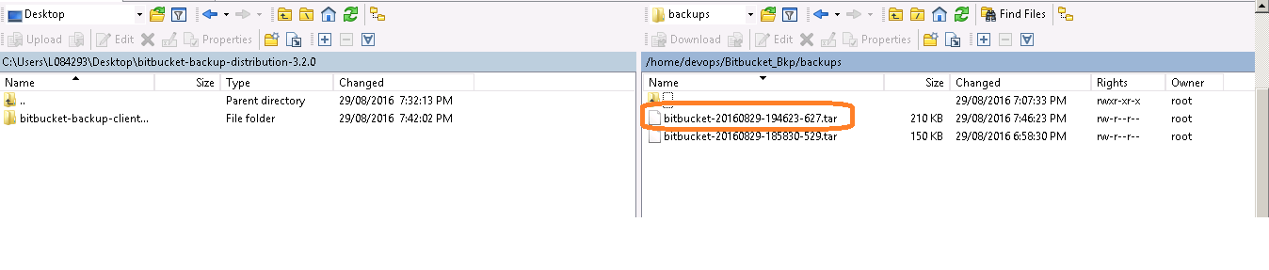

**Step 13:** Stop the current Bitbucket instance and uninstall the Bitbucket server to verify the restoration.

**Step 14:** Install Bitbucket server again using CA RA Flow and access the bitbucket through browser so that we can verify that none of the projects, users, groups and permissions are available as it’s a fresh installation as shown below:

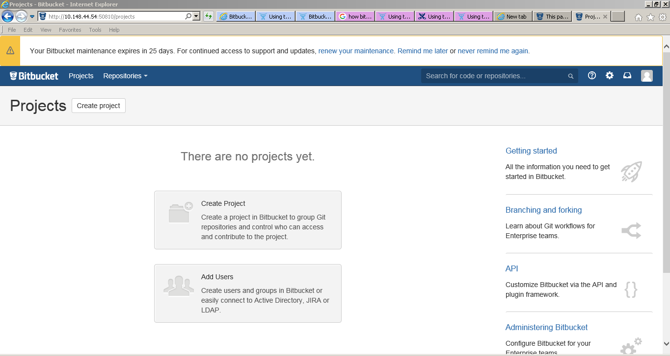

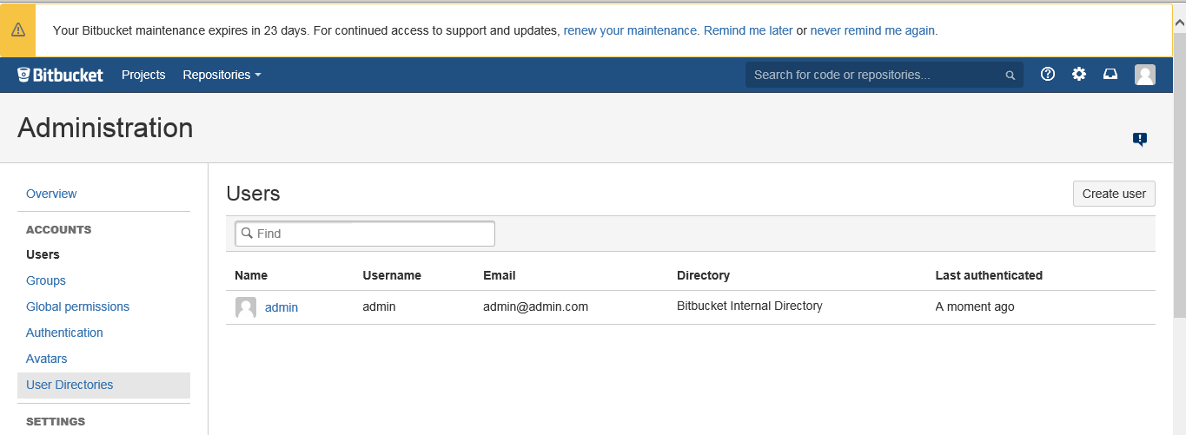

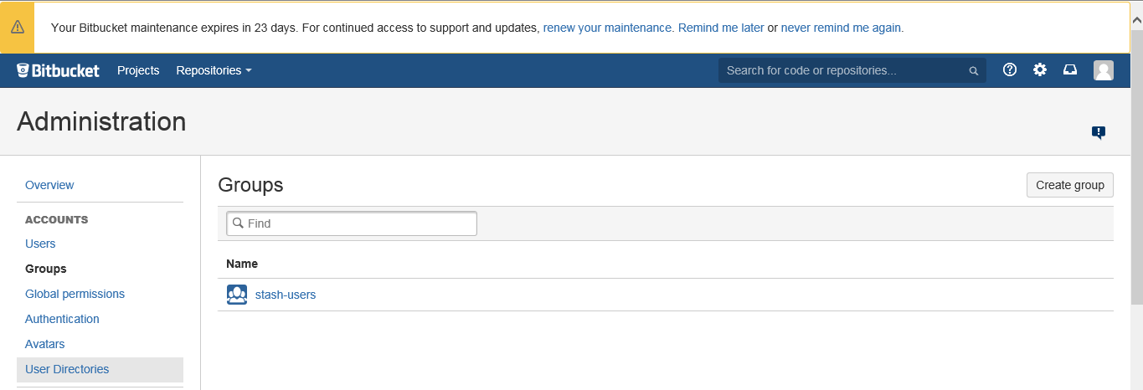

**Note:** admin user is created when we are starting the bitbucket for the first time and stash-users are the default group provided by bitbucket.

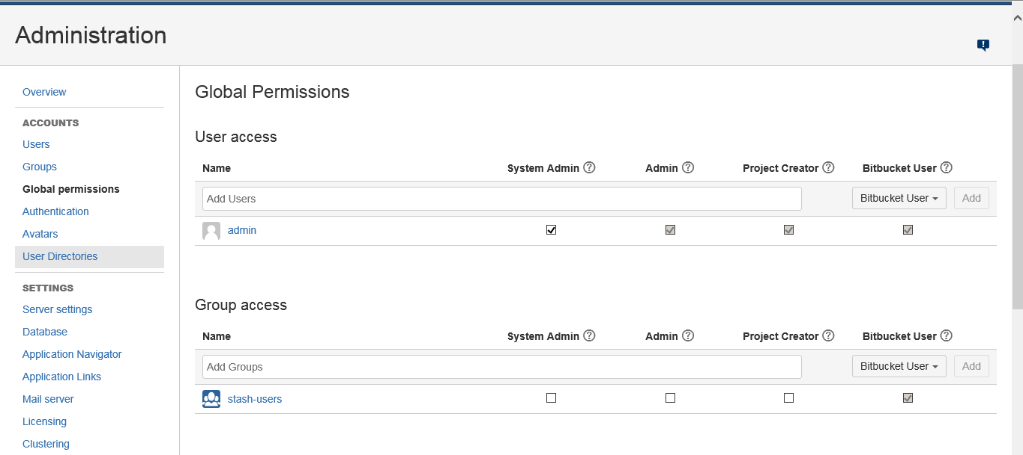

**Note:** There are no projects and repositories. Hence there will be no project and repository permissions.

**Step 15:** Stop the bitbucket instance and empty the bitbucket home directory as shown below:

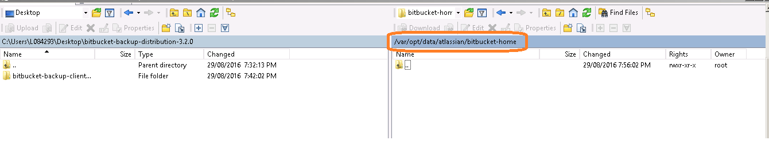

**Step 16:** Now restore/migrate the data by navigating to the bitbucket server backup client directory and by using the below command:

java -Dbitbucket.home="/var/opt/data/atlassian/bitbucket-home" -jar bitbucket-restore-client.jar /home/devops/Bitbucket_Bkp/backups/bitbucket-20160829-194623-627.tar

Once the above command executed successfully we can see the below output:

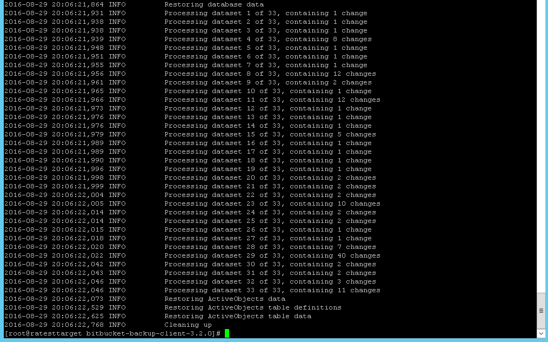

**Step 17:** Start the Bitbucket server instance. Validate all the steps from **step 2** to **step 9** to see if all the data is restored as shown below:

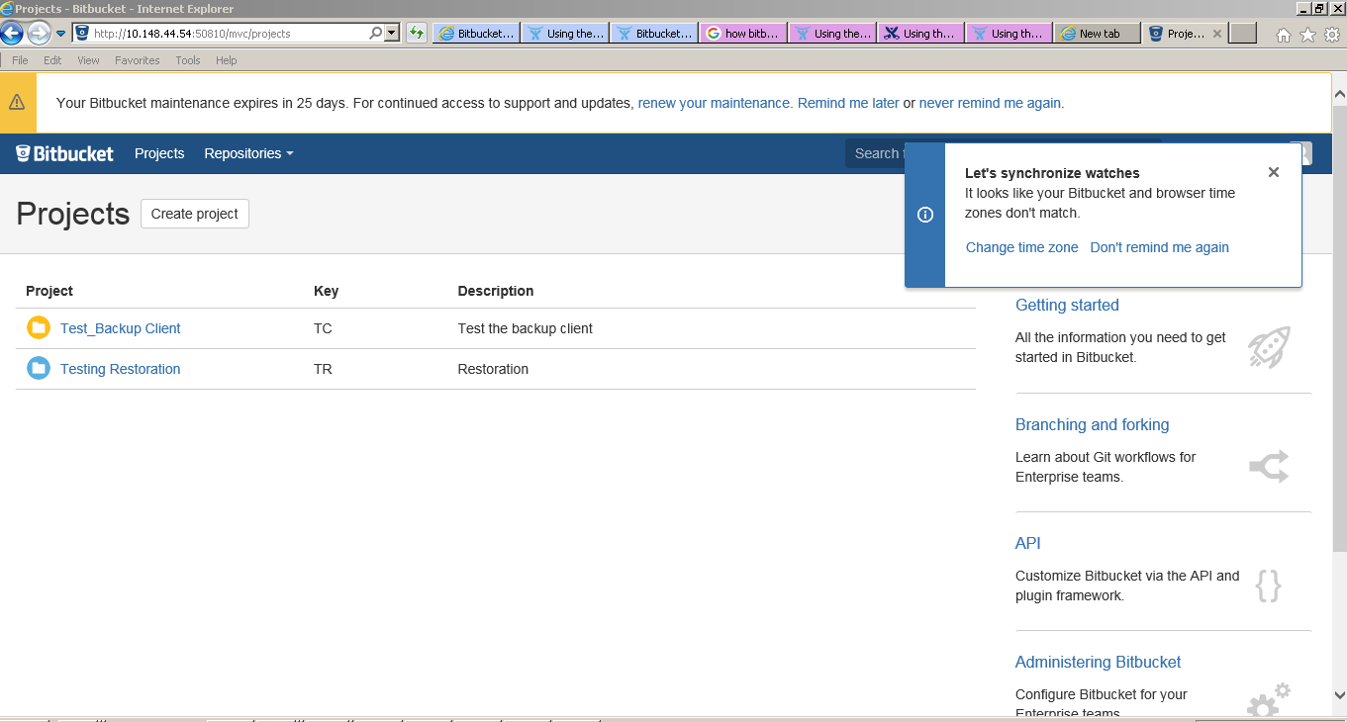















**Note:** We have tested the client only for the evaluation version. For external version as it contains DB configuration we need to follow some additional steps as described in the below URL:

<https://confluence.atlassian.com/bitbucketserver046/administering-bitbucket-server/advanced-actions/data-recovery-and-backups/using-the-bitbucket-server-backup-client>